The three videos provided give valuable tips. I am especially fond of the second video with the app suggestions. However, I already have a system that works quite well for me. The methodologies I administer for online learning are as follows:

I focus intently on being organized. I have created an entire file system for my studies, as shown in the following screenshots:

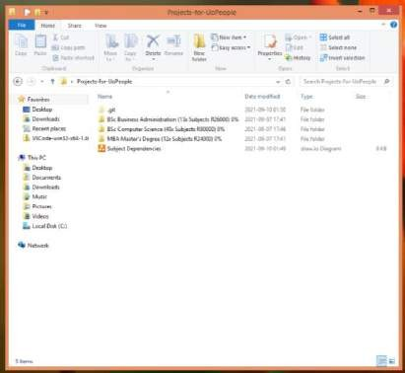

Figure 1 – I have planned out all of my studies at UoPeople. I would like to pursue 3 degrees as indicated in the screenshot above. I have calculated how many subjects each degree would require, as well as how much each would cost. I also have a percentage of completion at the end of each file name. They are all currently 0% as this is my first week of studying.

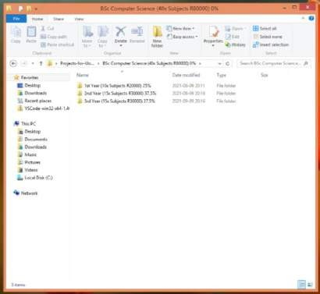

Figure 2 – I have calculated how many years each degree should take me to complete with the subjects selected.

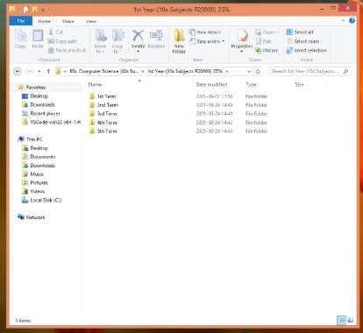

Figure 3 – I have planned out which subjects to take in each term of each year.

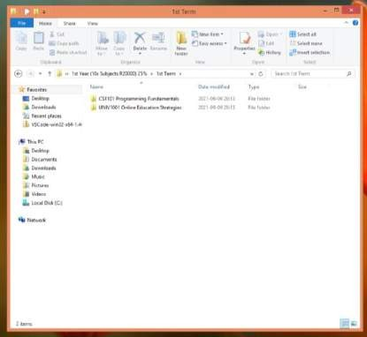

Figure 4 – As an example, for this first semester of the first year of the Bachelors of Science degree I have the two subjects shown in the screenshot above.

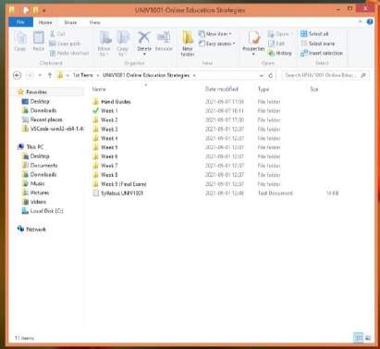

Figure 5 – For each individual subject I have broken down the coursework into weeks. Once a week has been completed, I change the file icon to a green checkmark as shown in the screenshot above. This is one of the small things I do to help motivate myself and stay organized.

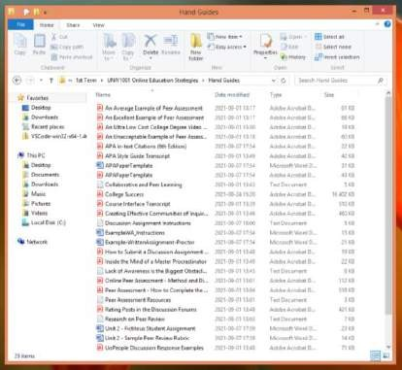

Figure 6 – I save all useful study materials in the Hand Guides folder for easy future access and simple referencing while completing assignments. I never have to look far to remember something.

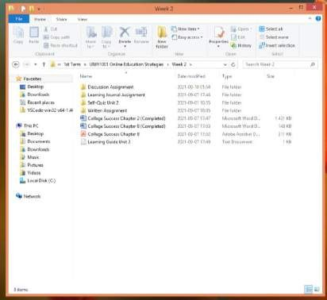

Figure 7 – Each week’s work is separated by assignment as indicated in the

screenshot above.

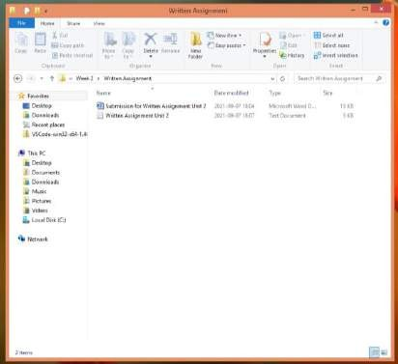

Figure 8 – As an example, the written assignment for week 2 (Unit 2) of UNIV1001 will contain the written assignment instructions and submissions documents together in one location.

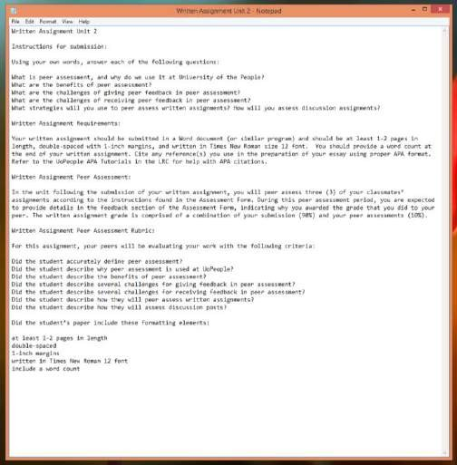

Figure 9 – The assignment instructions are always saved in the same folder as my work, with grading details to boot (as indicated in the screenshot above), to ensure I apply thoroughness and do not forget about any instructions as I can reference them

quickly before doing a final submission on my assignment. This way, I don’t forget

anything.

Having enough time to complete all your tasks is important, as well as prioritising which ones to do first. My little trick for this includes accessing the learning units the first day they become available each week and reading through everything for the week for each subject.

After skimming over all the work required for the week (important for getting the big picture) and saving all useful learning materials after studying and understanding them, I break the week’s work down into smaller chunks to make it more manageable and to enable me to plan my time accordingly. I open a new tab for each assignment I need to submit, and rearrange the tabs in a priority scale, completing the first tab first and the last tab last. By keeping each submission required open as a tab, I never forget to submit something.

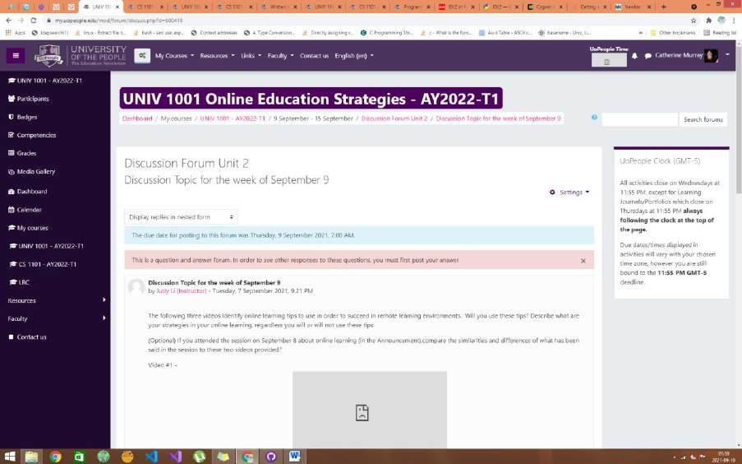

Figure 10 – My first priority for this week is the UNIV1001 Unit 2 Discussion Forum Submission.

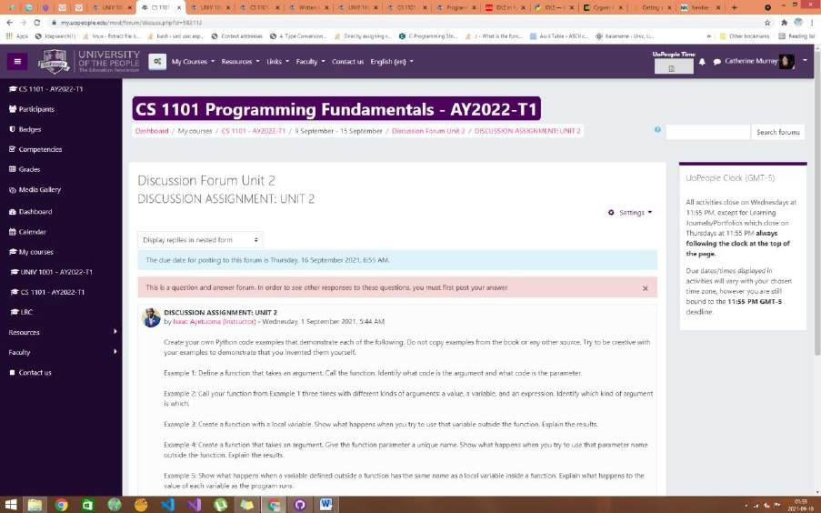

Figure 11 – My second priority for this week is the CS1101 Unit 2 Discussion Forum Submission. I find it easier to do the discussion forum for both subjects before moving on to the other assignments. I also find I learn plenty from the discussion forum, so prefer doing them as my first priority task to apply what I learn from them to other tasks.

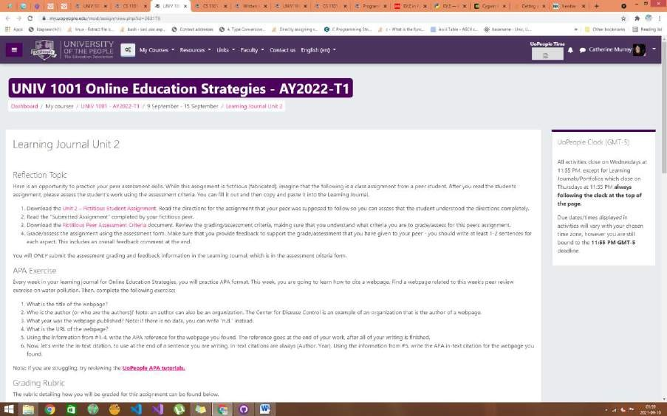

Figure 12 – The next two tasks in my priority list are the learning journals.

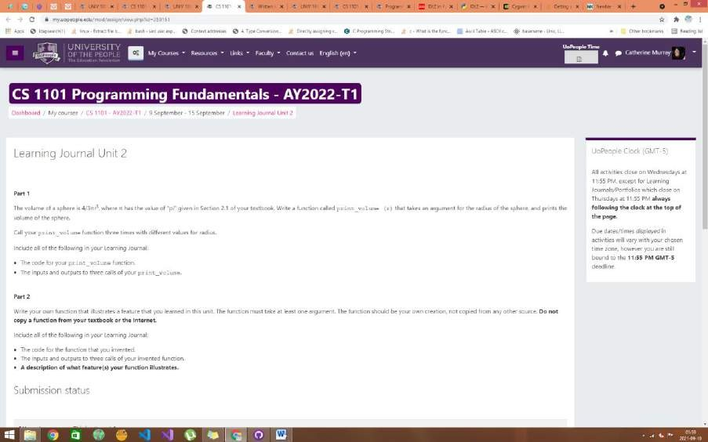

Figure 13 – I prefer always completing UNIV1001 before CS1101 in all submissions as I find UNIV1001 to be more educational regarding submissions and online studying.

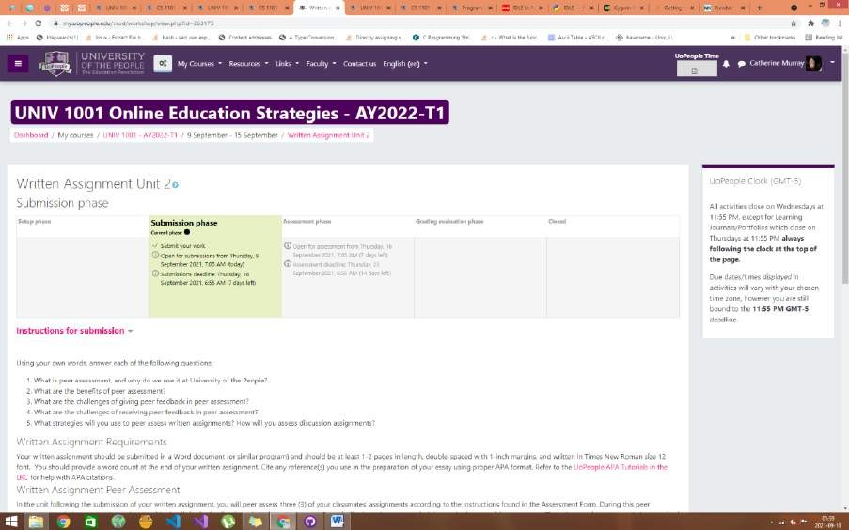

Figure 14 – I save the written assignments for later, as the discussion forums and learning journals tend to be less time consuming.

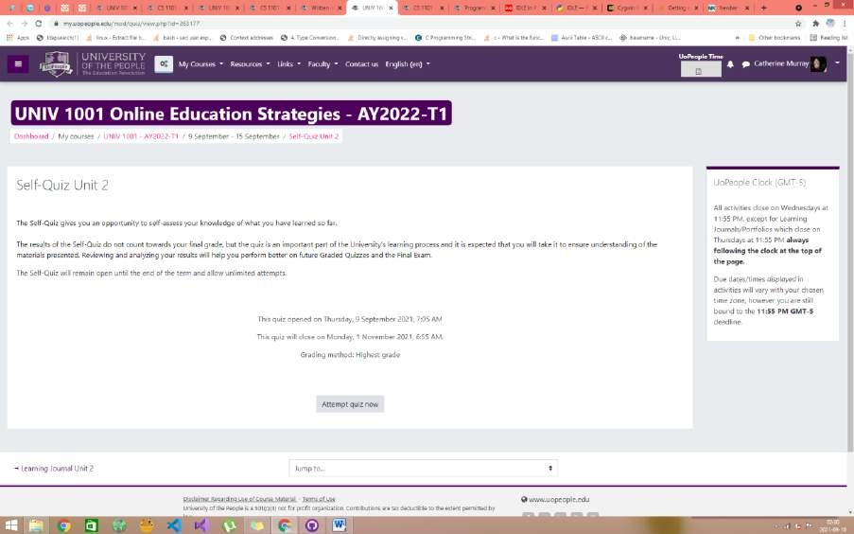

Figure 15 – I save the self-quiz for after most of the grunt work so I can fully focus on mastering all the content by taking it again and again until I am completely certain I fully understand every question.

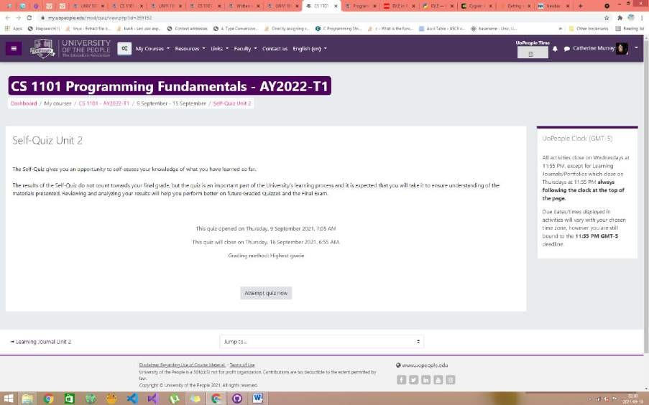

Figure 16 – I have 8 submissions expected from me for this week, and the order in which they appear in these screenshots is the order in which I plan to complete them. The self-quiz for CS1101 will be my 7th submission.

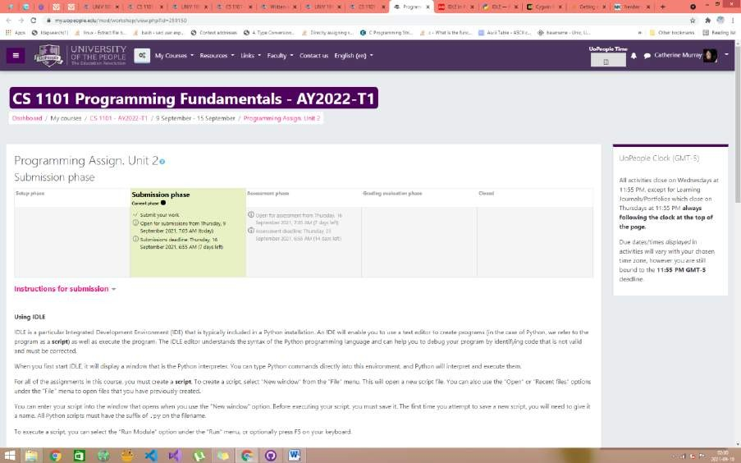

Figure 17 – I’m saving my programming assignment for last, as it is vital in this assignment that I pay special attention to detail. This assignment is where I will learn all the skills I will employ in my future job, so I do not want any other project weighing over me while working on this one. I want to complete everything else expected of me, and then give my full dedication and 100% focus to this last assignment.

Beyond being organized, I also have a little trick to staying motivated. I gamify my study work. In a video game, you tend to have progress bars that capture your experience and levels. I have a sticky note on my desktop that does the same with my study progress.

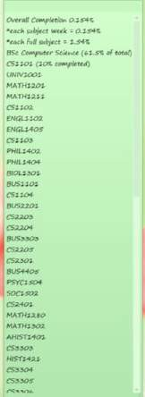

Figure 18 – I calculated what percentage each subject completion counts toward my overall goal and I use the sticky note captured in the screenshot above to keep track of it. It is extremely motivating to watch that percentage go up, even if it is incrementally as I have only just started. It helps to be able to visualize your progress.

I also have a dedicated working space in my room.

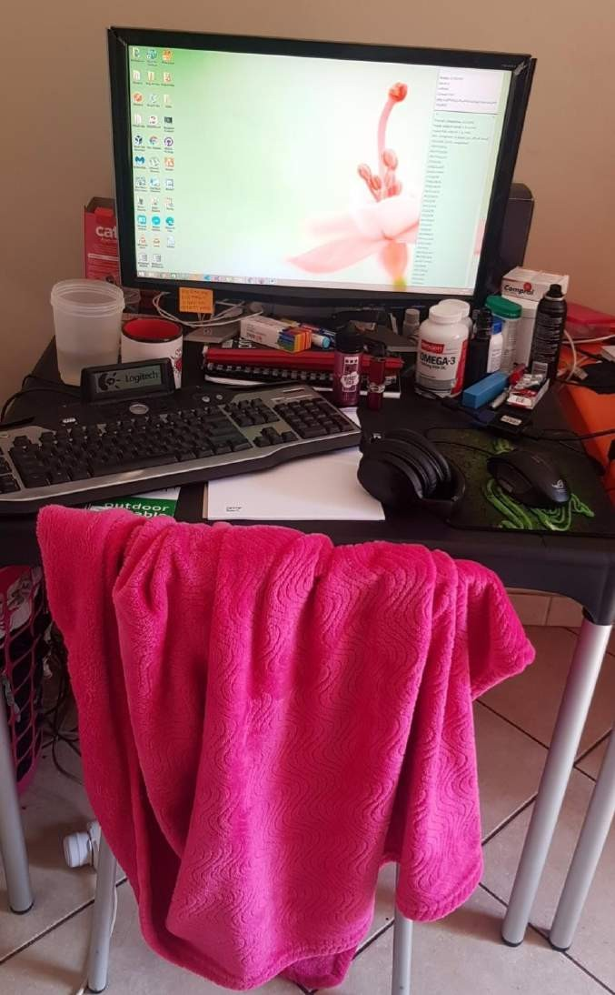

Figure 19 – It is small, but functional. This is my desk space where I study in the screenshot above.

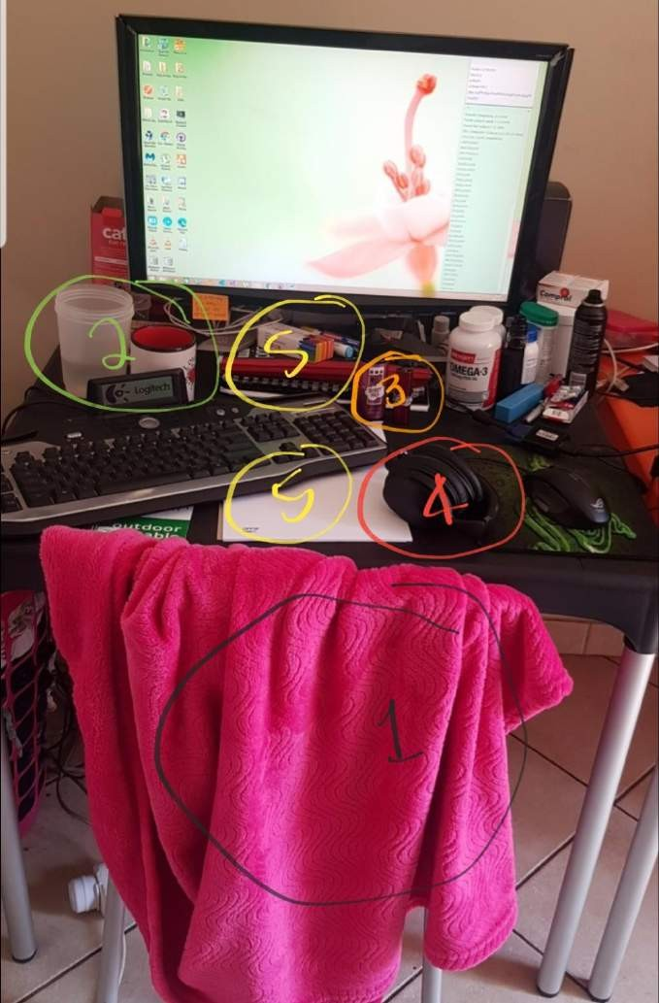

Figure 20 – I have a few things that help me avoid distraction and feel comfortable sitting for hours on end studying;

1. I have a soft pink fluffy blanket to keep my legs and feet warm from the tile floor and open window while I study.
2. Before sitting down and starting a project, I always make sure I have a cup of green tea and a jug of water so I don’t have to interrupt my focus to get up for a drink.
3. I always have my vape charged and my vape juice on hand, so that I don’t need to get up for these items.
4. I have noise cancelling headphones connected to my phone via Bluetooth. I created a playlist with some awesome beats, and when I need to focus I select a song I like and play it on repeat until I am done with my assignment.
5. I always keep a notepad and a variety of stationary nearby for quick scribbles or notes, rather than forget what I wanted to make a note of while searching for a working pen.

I also like utilizing an app called draw.io *¹*(2021) to help me digest complex materials or visualize a ton of information in an easy to absorb format. I often use it while working through hand guide chapters or writing a software program to visualize the different function

calls.

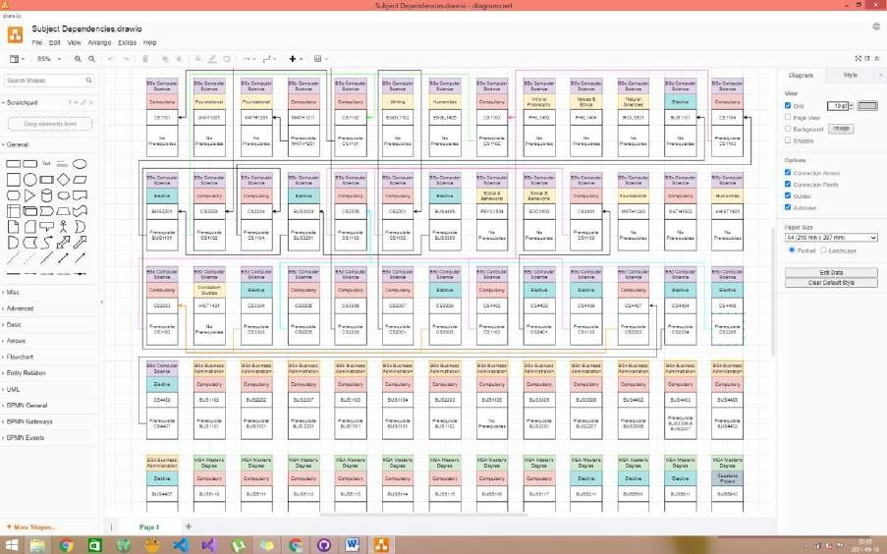

Figure 21 – The screenshot above is an example of a diagram I created using the draw.io app to help me visualize the subjects I plan on taking (their prerequisites/dependencies) to plan carefully which order I should take the subjects in.

The last thing I do is always make backups of all my work on GitHub *²*(*Getting Started with GitHub Desktop*, 2008). This is in case a computer crashes, as it’s not a valid excuse for missing a submission and it’s painful to lose your work and start all over again.

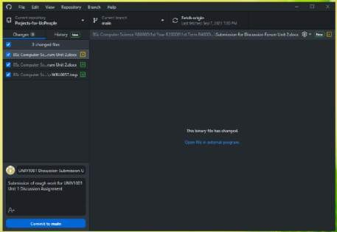

Figure 22 – I use GitHub’s Desktop application as indicated in the screenshot above.

Reference List:

1. C. (2021, September 2). *Product*. Draw.Io. <https://drawio-app.com/product/>
2. *Getting started with GitHub Desktop*. (2008, April 6). GitHub Docs. [https://docs.github.com/en/desktop/installing-and-configuring-github-](https://docs.github.com/en/desktop/installing-and-configuring-github-desktop/overview/getting-started-with-github-desktop)

[desktop/overview/getting-started-with-github-desktop](https://docs.github.com/en/desktop/installing-and-configuring-github-desktop/overview/getting-started-with-github-desktop)

Word Count (354)